^{th} Annual
Tacoma Sportsman's club

Kids Fishing Derby
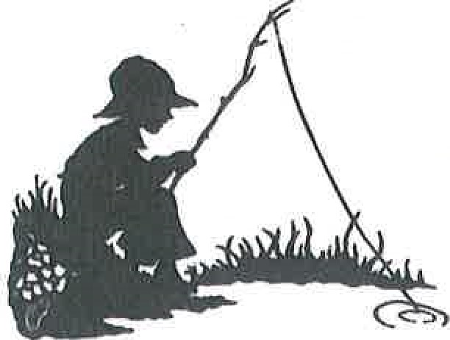
Saturday May 19th 2018
Bradley Lake Park 531 31st Ave. SE
Puyallup WA 98374
7am - Noon
Kids 14 and under come and fish for free!
Poles and bait will be provided. Prizes will be awarded.
253-537-6151 www.tacomassportsmensclub.com
Also Sponsored by these fine retailers

